Project name : Daily-Task-list

Problem statement :

* I personally find difficult to set my daily goals and complete my daily tasks.
* Even many other students can’t do productive work if they don’t set their daily tasks.

Solution :

* To manage and complete their daily task and goals. This small app definitely gonna help
* Where you can add multiple daily tasks that u want to complete and delete once u complete it And track your remaining task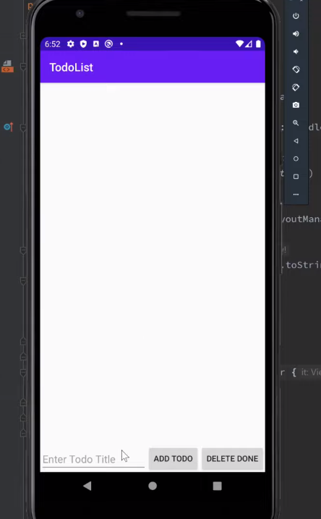

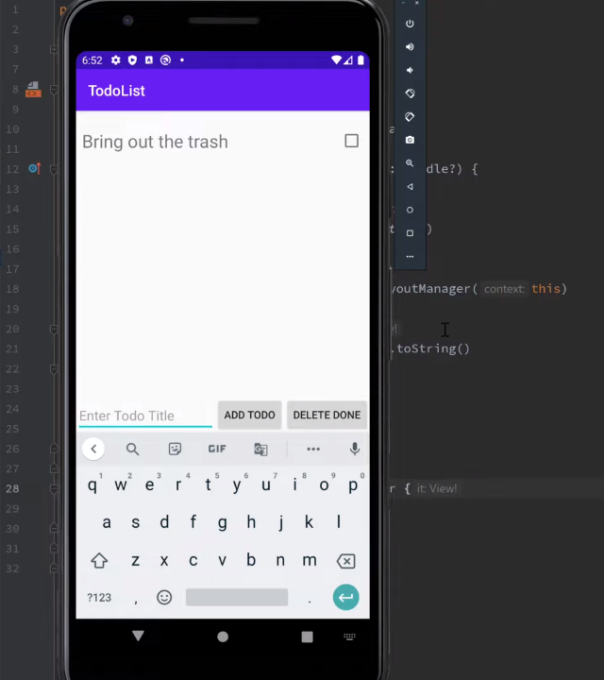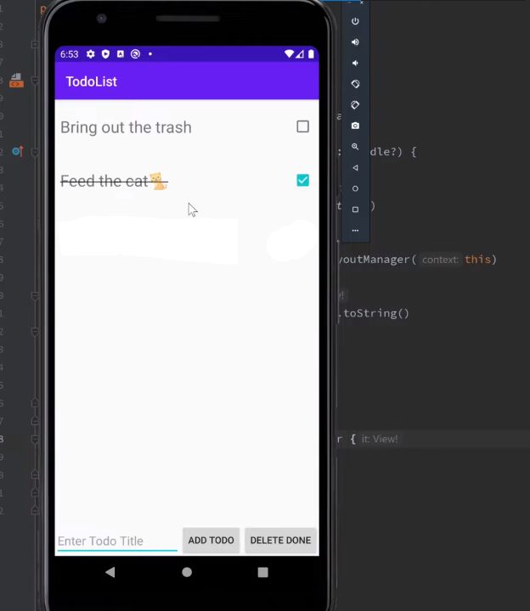

Functionality:

- to take input of tasks from user and add it to list of daily tasks

Application link:

https://github.com/omnalagune/Daily-Task-list